Unit 1 Communication

Communication
- Choose the correct words.
Cathy (1) Hi / Bye, Charlie.
Charlie (2) See you later / Hello, Cathy. How are you?
Cathy Fine, thanks.
Charlie (3) What’s / How’s your phone number?
Cathy (4) I’m / It’s six three nine double oh two.
Charlie 639022.
Cathy No, (5) 639002 / 693002.
Charlie Oh, (6) hi / thanks Cathy. See you later.
Cathy OK, Charlie. Bye.
- Complete the sentences. Choose from these words.
Bye - How - Good morning - fine, thanks - That’s - See you
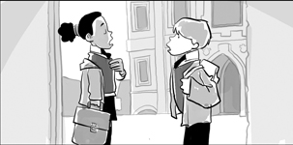
Mandy (1) , John. (2) are you?
John Hello, Mandy. I’m (3) . And you?
Mandy I’m fine, thank you.
John (4) good.
Mandy (5) later, John.
John Yes. (6) , Mandy.

